## Flutter Firebase CLI Very Important

Add Firebase to your Flutter app

Error creation

[Firebase CLI v7.0.0 is incompatible with Node.js v6.17.1 Please upgrade Node.js to version >= 8.0.0](https://stackoverflow.com/questions/56571287/firebase-cli-v7-0-0-is-incompatible-with-node-js-v6-17-1-please-upgrade-node-js)

Solution From Stack overflow

#### Node Install url:

https://nodejs.org/en/download/

#### 1.npm install -g firebase-tools@10.9.2 (CMD)

#### 2.firebase login (CMD)

#### 3.Then click **Yes (CMD)**

#### 4. Go to Google Sign in Page

#### 5.Give Allow Permission

#### 6.It goes to Firebase CliLogin Successfull Page

Woohoo!

Firebase CLI Login Successful

You are logged in to the Firebase Command-Line interface. You can immediately close this window and continue using the CLI.

<http://localhost:9005/?state=842918015&code=4/0AeaYSHCxf5lbaicTOfivbOOaYmWHLrsFob007L5mzJb_e-XspBLmCtDY37kJH5GnvhYFcg&scope=email%20https://www.googleapis.com/auth/userinfo.email%20openid%20https://www.googleapis.com/auth/cloudplatformprojects.readonly%20https://www.googleapis.com/auth/firebase%20https://www.googleapis.com/auth/cloud-platform&authuser=0&prompt=consent> - URL

#### 7.Go to terminal enter below command

dart pub global activate flutterfire_cli (CMD)

#### 8.After dart pub global activate flutterfire_cli cmd

+ **ansi_styles** 0.3.2+1s... (2.5s)

+ **args** 2.4.2

+ **async** 2.11.0

+ **boolean_selector** 2.1.1

+ **characters** 1.3.0

+ **ci** 0.1.0

+ **cli_util** 0.3.5 (0.4.1 available)

+ **clock** 1.1.1

+ **collection** 1.18.0

+ **dart_console** 1.2.0

+ **deep_pick** 0.10.0 (1.0.0 available)

+ **ffi** 2.1.2

+ **file** 6.1.4 (7.0.0 available)

+ **flutterfire_cli** 0.2.7

+ **http** 0.13.6 (1.2.1 available)

+ **http_parser** 4.0.2

+ **interact** 2.2.0

+ **intl** 0.18.1 (0.19.0 available)

+ **json_annotation** 4.8.1

+ **matcher** 0.12.16+1

+ **meta** 1.12.0

+ **path** 1.9.0

+ **petitparser** 6.0.2

+ **platform** 3.1.4

+ **process** 4.2.4 (5.0.2 available)

+ **pub_semver** 2.1.4

+ **pub_updater** 0.2.4 (0.4.0 available)

+ **pubspec** 2.3.0

+ **quiver** 3.2.1

+ **source_span** 1.10.0

+ **stack_trace** 1.11.1

+ **stream_channel** 2.1.2

+ **string_scanner** 1.2.0

+ **term_glyph** 1.2.1

+ **test_api** 0.7.0

+ **tint** 2.0.1

+ **typed_data** 1.3.2

+ **uri** 1.0.0

+ **win32** 5.3.0

+ **xml** 6.5.0

+ **yaml** 3.1.2

Building package executables... (7.3s)

Built **flutterfire_cli:flutterfire**.

Installed executable **flutterfire**.

Warning: Pub installs executables into **$HOME/.pub-cache/bin**, which is not on your path.

You can fix that by adding this to your shell's config file (.bashrc, .bash_profile, etc.):

**export PATH="$PATH":"$HOME/.pub-cache/bin"**

Activated **flutterfire_cli** 0.2.7.

#### 9.Next (only mac)

mervinthomas-3:~ apple$ echo 'export PATH="$PATH":"$HOME/.pub-cache/bin"'>>~/.bash_profile

mervinthomas-3:~ apple$ tail -2 ~/.bash_profile

export PATH="$PATH":"$HOME/.pub-cache/bin”

#### 10.New Projects Creation:

flutter create demo --template=app --platforms=ios,android,macos,web --org=com.google.firebase.presents (CMD)

flutter create fluttercookbook --template=app --platforms=ios,android,macos,web --org=com.codelooms (CMD)

##### Firebase Initialise in main.dart

Future<void> main() async {

WidgetsFlutterBinding.ensureInitialized();

await Firebase.initializeApp(

options: DefaultFirebaseOptions.currentPlatform,

);

runApp(const MyApp());

}

#### 11. Firebase core add

flutter pub add firebase_core (CMD)

#### 12.After flutter pub add firebase_core (CMD)

Resolving dependencies...

+ **firebase_core** 2.27.1

+ **firebase_core_platform_interface** 5.0.0

+ **firebase_core_web** 2.12.0

+ **flutter_web_plugins** 0.0.0 from sdk flutter

+ **js** 0.6.7 (0.7.1 available)

**leak_tracker** 10.0.0 (10.0.4 available)

**leak_tracker_flutter_testing** 2.0.1 (3.0.3 available)

**leak_tracker_testing** 2.0.1 (3.0.1 available)

**material_color_utilities** 0.8.0 (0.11.1 available)

**meta** 1.11.0 (1.12.0 available)

+ **plugin_platform_interface** 2.1.8

**test_api** 0.6.1 (0.7.0 available)

**vm_service** 13.0.0 (14.2.0 available)

+ **web** 0.5.1

Changed 7 dependencies!

8 packages have newer versions incompatible with dependency constraints.

Try `flutter pub outdated` for more information.

mervinthomas-3:demo apple$ flutter pub outdated

Showing outdated packages.

[*] indicates versions that are not the latest available.

**Package Name** **Current** **Upgradable** **Resolvable** **Latest**

**direct dependencies: all up-to-date.**

**dev_dependencies: all up-to-date.**

all dependencies are up-to-date.

#### 13. Enter flutterfire configure Command

##### Hint: Windows flutterfire configure is not working windows

flutterfire configure is not working windows.

Solution:

Sample Path : C:\Users\YOU-USER-NAME\AppData\Local\Pub\Cache\bin

When step 7 followed in windows one windows path will create.

Copy that path with bin

Go to the environment variable and system variable and select the path and paste it.it will work.

The

mervinthomas-3:demo apple$ flutterfire configure (CMD)

i Found 18 Firebase projects.

✔ **Select a Firebase project to configure your Flutter application with** · cl-ott (cl-ott)

? **Which platforms should your configuration support (use arrow keys & space to s**✔ **Which platforms should your configuration support (use arrow keys & space to select)?** · ios, macos, web

i **Firebase ios app com.google.firebase.presents.demo is not registered on Firebase project cl-ott.**

i **Registered a new Firebase ios app on Firebase project cl-ott.**

i **Firebase macos app com.google.firebase.presents.demo.RunnerTests is not registered on Firebase project cl-ott.**

i **Registered a new Firebase macos app on Firebase project cl-ott.**

i **Firebase web app demo (web) is not registered on Firebase project cl-ott.**

i **Registered a new Firebase web app on Firebase project cl-ott.**

Firebase configuration file lib/firebase_options.dart generated successfully with the following Firebase apps:

**Platform** **Firebase App Id**

web 1:186419238970:web:f706bd591e24074ac0fd03

ios 1:186419238970:ios:cc9c22efc0107fdec0fd03

macos 1:186419238970:ios:db50bb04a89ed999c0fd03

Learn more about using this file and next steps from the documentation:

> https://firebase.google.com/docs/flutter/setup

mervinthomas-3:demo apple$

Note: Just select android then give enter

### Flutter Firebase New Authentication:

<https://github.com/firebase/quickstart-flutter/tree/main/authentication>

flutter pub add firebase_core

flutter pub add firebase_auth

flutter pub add firebase_ui_auth

firebase emulators:start

firebase init emulators

? Please select an option: Use an existing project

? Select a default Firebase project for this directory: (Use arrow keys)

❯ authfb (authfb) // select authfb

Output:

? Which Firebase emulators do you want to set up? Press Space to select emulators, then Enter to confirm your choices.

i Writing configuration info to firebase.json...

i Writing project information to .firebaserc...

✔ Firebase initialization complete!

Flutter clean

Working directory:

/Users/apple/Public/mobapps/flutter/stalin/fbauth working good

Go to Firebase Console and add user

<https://console.firebase.google.com/u/0/project/authfb/authentication/users>

For example:

User:

[stalingalaxy@gmail.com](mailto:stalingalaxy@gmail.com) / galaxy12#

Go to Sign in method:

Add New Provider:

Enable Email/Password

#### 14.Multidex Enabled Support:

File Path: Android /app/build.gradle

plugins **{**

id "com.android.application"

id "kotlin-android"

id "dev.flutter.flutter-gradle-plugin"

**}**

def localProperties = new Properties()

def localPropertiesFile = rootProject.file('local.properties')

if (localPropertiesFile.exists()) {

localPropertiesFile.withReader('UTF-8') **{** reader **->**

localProperties.load(reader)

**}**

}

def flutterVersionCode = localProperties.getProperty('flutter.versionCode')

if (flutterVersionCode == null) {

flutterVersionCode = '1'

}

def flutterVersionName = localProperties.getProperty('flutter.versionName')

if (flutterVersionName == null) {

flutterVersionName = '1.0'

}

android **{**

namespace "com.google.firebase.presents.demo"

compileSdk flutter.compileSdkVersion

ndkVersion flutter.ndkVersion

compileOptions **{**

sourceCompatibility JavaVersion.VERSION_1_8

targetCompatibility JavaVersion.VERSION_1_8

**}**

kotlinOptions **{**

jvmTarget = '1.8'

**}**

sourceSets **{**

main.java.srcDirs += 'src/main/kotlin'

**}**

defaultConfig **{**

*// TODO: Specify your own unique Application ID (https://developer.android.com/studio/build/application-id.html).*

applicationId "com.google.firebase.presents.demo"

*// You can update the following values to match your application needs.*

*// For more information, see: https://docs.flutter.dev/deployment/android#reviewing-the-gradle-build-configuration.*

minSdkVersion flutter.minSdkVersion

targetSdkVersion flutter.targetSdkVersion

versionCode flutterVersionCode.toInteger()

versionName flutterVersionName

multiDexEnabled true

**}**

buildTypes **{**

release **{**

*// TODO: Add your own signing config for the release build.*

*// Signing with the debug keys for now, so `flutter run --release` works.*

signingConfig signingConfigs.debug

**}**

**}**

**}**

flutter **{**

source '../..'

**}**

dependencies **{**

implementation 'com.android.support:multidex:1.0.3'

**}**

#### 15.Fire Base Project Creation:

1. <https://console.firebase.google.com/>

##### Required Packages:

flutter pub add google_sign_in

firebase_core: ^2.27.1

firebase_auth: ^4.17.9

google_sign_in: ^6.2.1

##### Go to Console link

Add New Projects

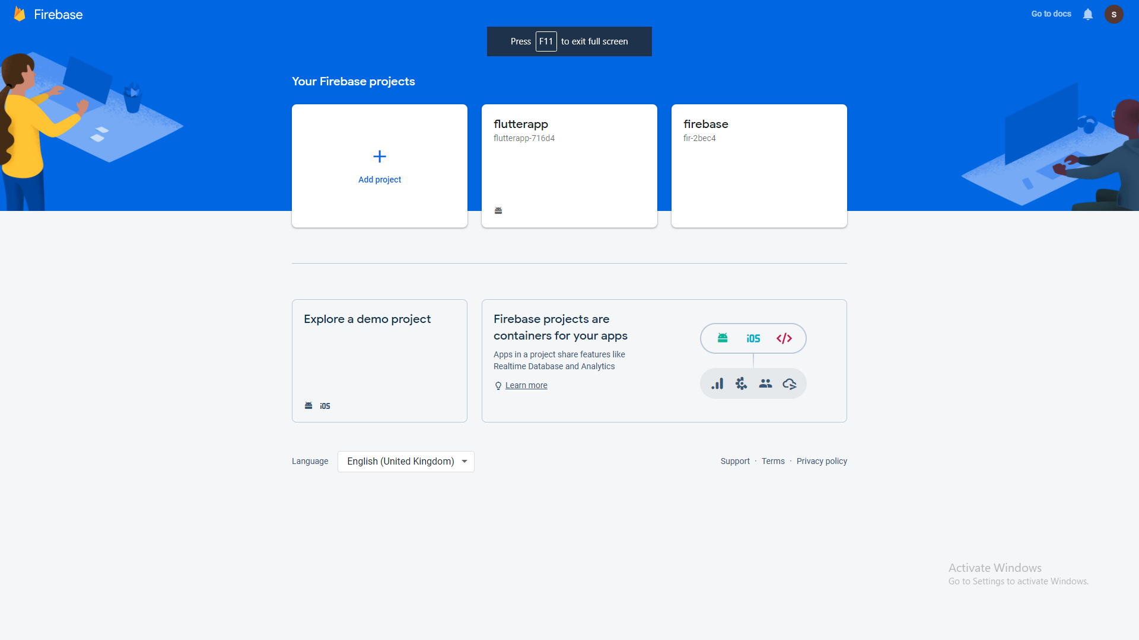

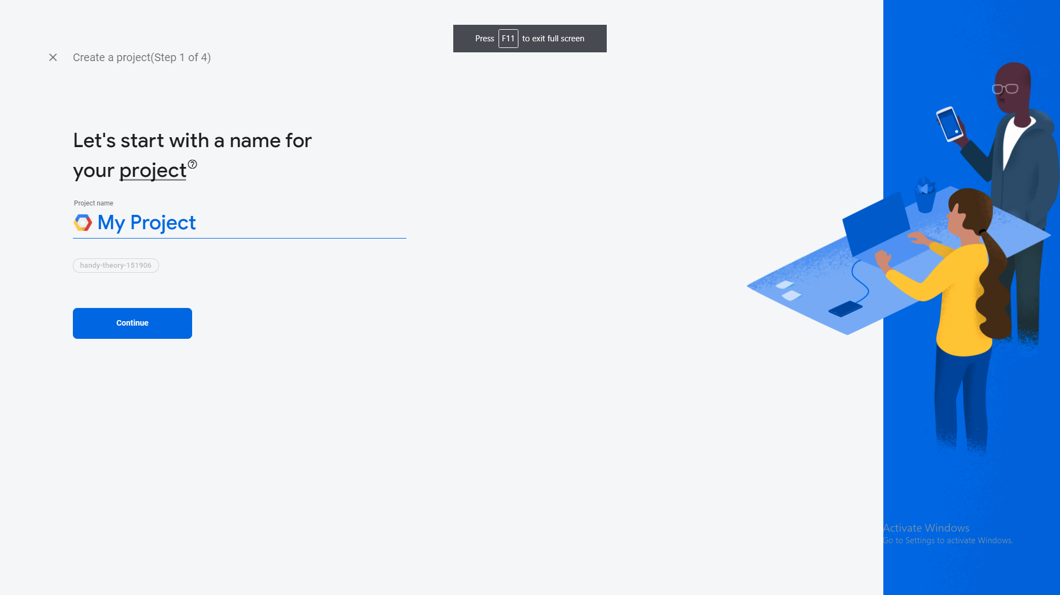

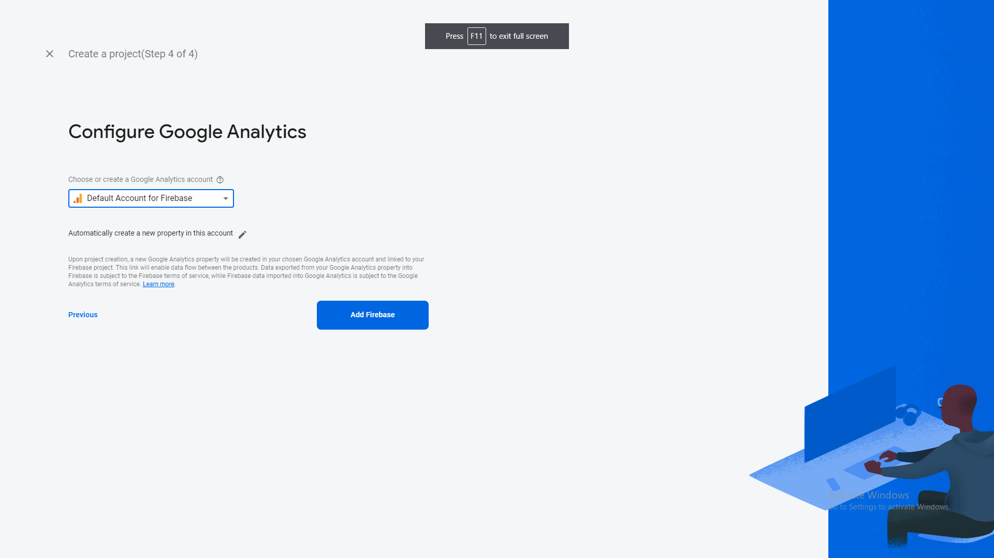

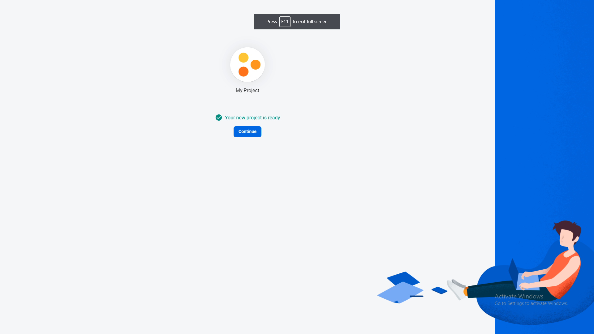

##### 

##### Click Android Project:

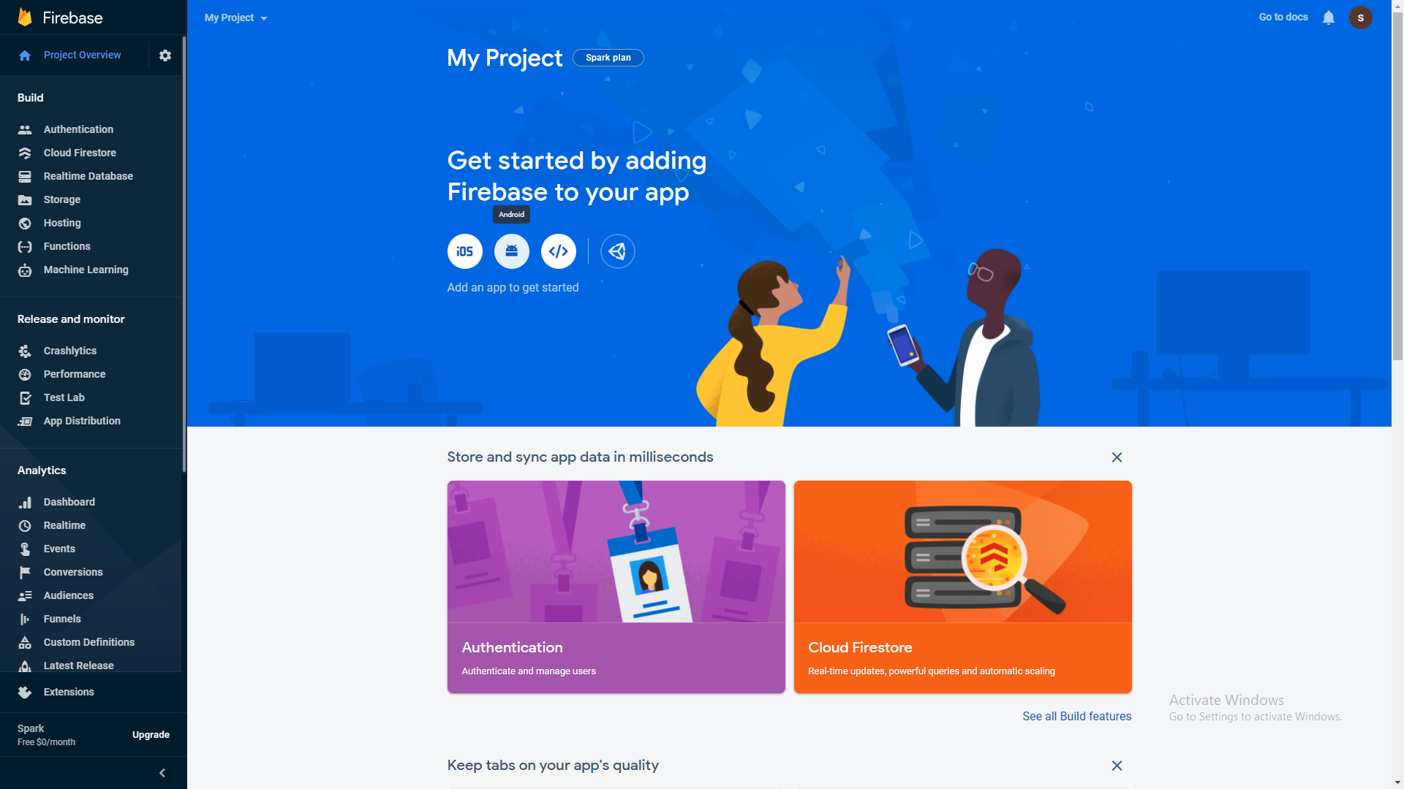

##### 

##### Office Vscode Keystore:

keytool -list -v -keystore C:\Users\NIC\.android\debug.keystore

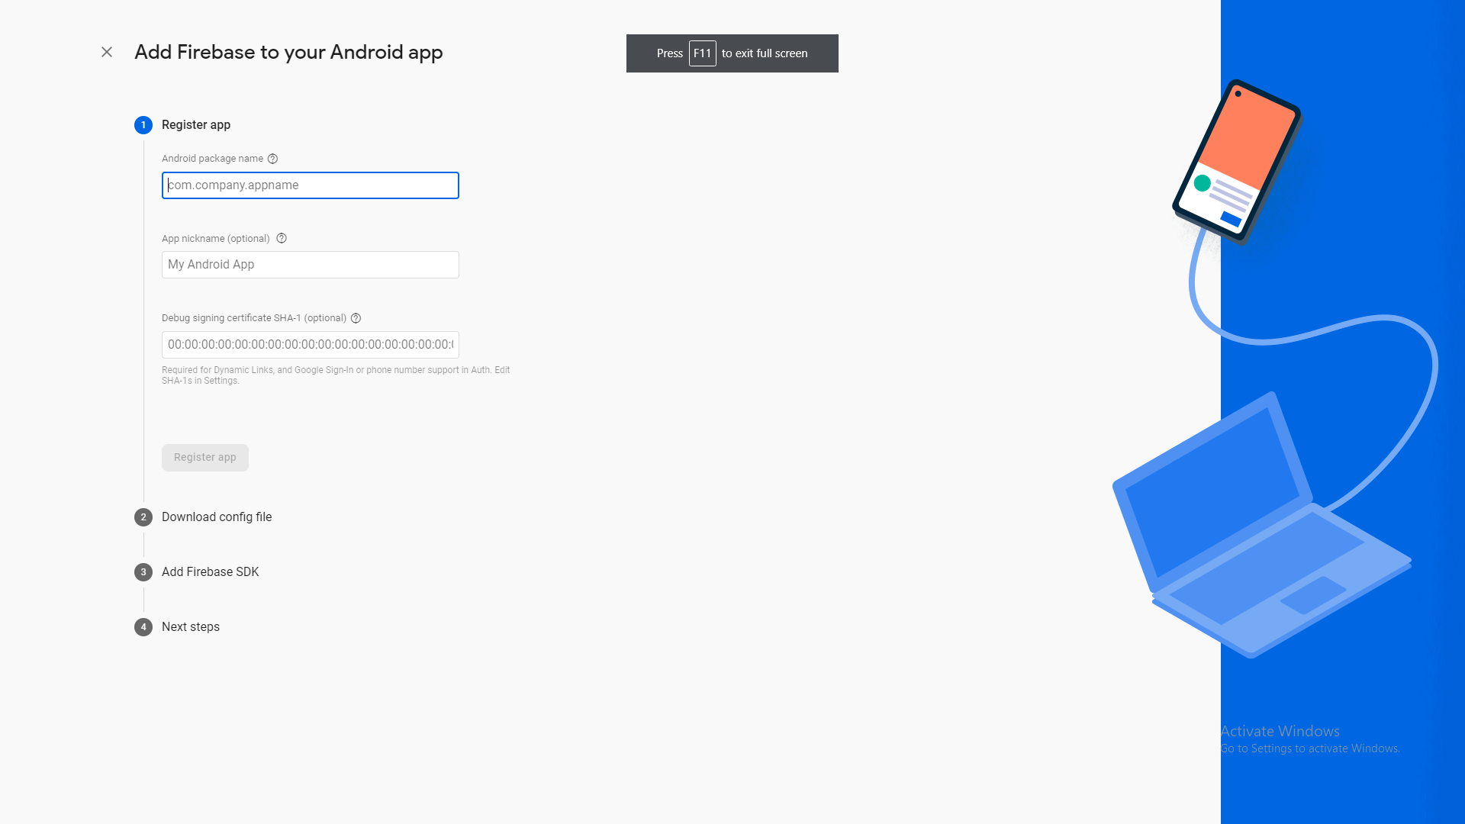

##### 

##### 

##### 

##### 

##### 

##### Enter android package name:

##### Go to android->app->src->AndroidManifest.xml

##### Enter Package name:

##### Com.example.basefire

##### Debug signing certificate SHA-1

Mac

keytool -list -v -keystore ~/.android/debug.keystore -alias androiddebugkey -storepass android -keypass android

##### [Generate SHA-1 for Flutter/React-Native/Android-Native app](https://stackoverflow.com/questions/51845559/generate-sha-1-for-flutter-react-native-android-native-app)

Enter Password : android

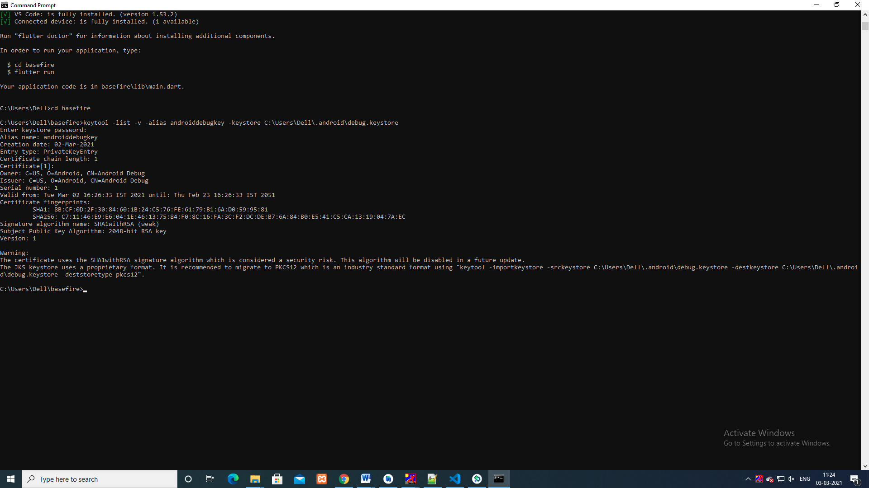

Select sha key and Paste it

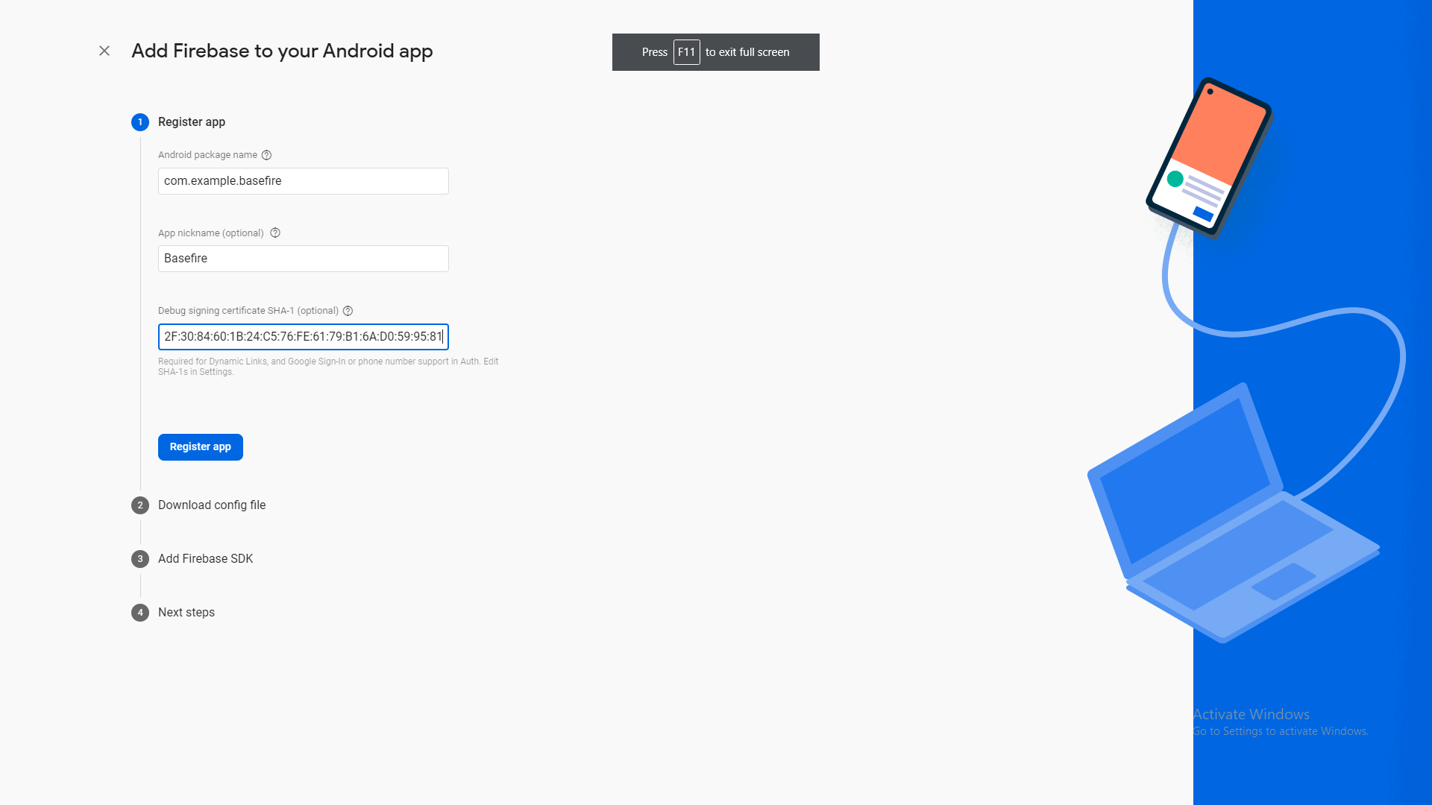

Save Console

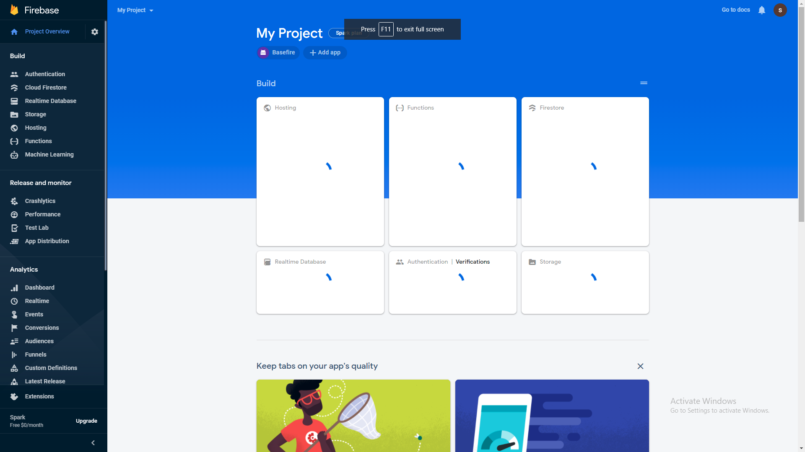

#### Sample Code for Google Sign in:

import 'package:firebase_core/firebase_core.dart';

import 'package:flutter/material.dart';

import 'package:firebase_auth/firebase_auth.dart';

import 'package:google_sign_in/google_sign_in.dart';

import 'firebase_options.dart';

Future<void> main() async {

WidgetsFlutterBinding.ensureInitialized();

await Firebase.initializeApp(

options: DefaultFirebaseOptions.currentPlatform,

);

runApp(const MyApp());

}

class MyApp extends StatelessWidget {

const MyApp({super.key});

@override

Widget build(BuildContext context) {

return MaterialApp(

title: 'Google Sign-In Example',

theme: ThemeData(

primarySwatch: Colors.blue,

),

home: HomePage(),

);

}

}

class HomePage extends StatelessWidget {

final FirebaseAuth _auth = FirebaseAuth.instance;

final GoogleSignIn googleSignIn = GoogleSignIn();

HomePage({super.key});

@override

Widget build(BuildContext context) {

return Scaffold(

appBar: AppBar(

title: const Text('Home Page'),

),

body: Center(

child: ElevatedButton(

onPressed: () async {

await _handleSignIn(context);

},

child: const Text('Sign in with Google'),

),

),

);

}

Future<void> _handleSignIn(BuildContext context) async {

try {

final GoogleSignInAccount? googleUser = await googleSignIn.signIn();

if (googleUser != null) {

final GoogleSignInAuthentication googleAuth =

await googleUser.authentication;

final OAuthCredential credential = GoogleAuthProvider.credential(

accessToken: googleAuth.accessToken,

idToken: googleAuth.idToken,

);

final UserCredential userCredential =

await _auth.signInWithCredential(credential);

final User? user = userCredential.user;

if (user != null) {

Navigator.pushReplacement(

context,

MaterialPageRoute(

builder: (context) => UserInfoPage(user: user),

),

);

} else {

// Show error message or handle sign-in failure

print('Sign-in failed');

}

} else {

// Show error message or handle sign-in failure

print('Sign-in failed');

}

} catch (e) {

print('Error during Google sign-in: $e');

// Show error message or handle sign-in failure

}

}

}

class UserInfoPage extends StatelessWidget {

final User user;

const UserInfoPage({super.key, required this.user});

@override

Widget build(BuildContext context) {

return Scaffold(

appBar: AppBar(

title: const Text('User Info'),

actions: [

IconButton(

onPressed: () async {

await FirebaseAuth.instance.signOut();

await GoogleSignIn().signOut();

Navigator.pushReplacement(

context,

MaterialPageRoute(

builder: (context) => HomePage(),

),

);

},

icon: const Icon(Icons.logout),

),

],

),

body: Center(

child: Column(

mainAxisAlignment: MainAxisAlignment.center,

children: [

Text(

'Welcome, ${user.displayName}',

style: const TextStyle(fontSize: 24),

),

const SizedBox(height: 20),

Text(

'Email: ${user.email}',

style: const TextStyle(fontSize: 18),

),

const SizedBox(height: 20),

Text(

'User ID: ${user.uid}',

style: const TextStyle(fontSize: 18),

),

],

),

),

);

}

}

##### 

##### Flutter Face Book Firebase

URL : <https://firebase.flutter.dev/docs/auth/social/>

<https://developers.facebook.com/apps/>

Click particular Projects